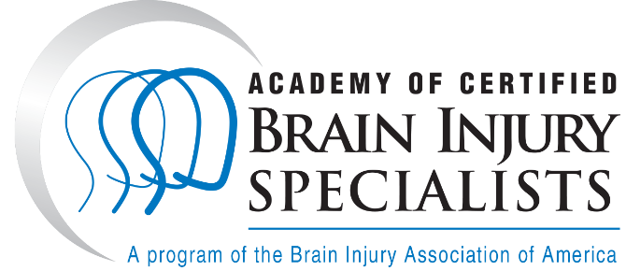

Press Release: General Use
[Organization name] Staff Holds Nationally Recognized Brain Injury Credential
[Organization’s City, STATE] – The Brain Injury Association of America’s Academy of Certified Brain Injury Specialists (ACBIS) is the largest national program providing education, training, certification, and ongoing resources for multi-disciplinary specialists in the brain injury community. ACBIS offers a certification program for professionals working in brain injury services to earn a nationally recognized credential: Certified Brain Injury Specialist (CBIS). This certification is administered by the Brain Injury Association of America and involves formal coursework and a written examination. Across the country, there are more than 7,000 professionals with CBIS certification.
The current total number of regularly staffed clinicians at [organization name] who have earned and maintained this certification is [number] of [number] [(percent %)]. This number signifies not only [organization name]’s commitment to excellence in supporting the specialization of its clinicians, but also represents the practitioners’ commitment to the population they serve.
“[Quote by organization’s leader regarding what it means to be cared for by someone who is CBIS certified].”
While all of these clinicians must meet certain standards in continuing education set by their individual professional licensing boards, in order to maintain their CBIS certification, they must complete 10 hours of continuing education specific to brain injury each year.
[Organization name] values CBIS certified staff as the certification gives clinicians the tools to understand the unique needs of persons recovering from brain injury and requires certificants to stay abreast of current resources in the field.
“[Quote by organization’s leader regarding why the organization finds value in employing certified staff].”
To learn more about ACBIS and the Brain Injury Association of America, visit www.biausa.org/acbis.

